19. Perform Edge Detection Using Sobel Matrix Along X and Y (XY Axis)
Aim
To perform edge detection on an image using the Sobel operator along both X and Y axes in Python with OpenCV.
Procedure
- Import the OpenCV and NumPy libraries.
- Read the input image.
- Convert the image to grayscale.
- Apply the Sobel operator along the X-axis.
- Apply the Sobel operator along the Y-axis.
- Convert both outputs to absolute values.
- Combine the X and Y edge images.
- Display the original image and the combined Sobel edge image.
- Close all windows after a key is pressed.

Python Code
import cv2
# Read the image
image = cv2.imread("image.jpg")
# Convert to grayscale
gray = cv2.cvtColor(image, cv2.COLOR_BGR2GRAY)
# Apply Sobel along X-axis
sobel_x = cv2.Sobel(gray, cv2.CV_64F, 1, 0, ksize=3)
# Apply Sobel along Y-axis
sobel_y = cv2.Sobel(gray, cv2.CV_64F, 0, 1, ksize=3)
# Convert to absolute values
sobel_x = cv2.convertScaleAbs(sobel_x)
sobel_y = cv2.convertScaleAbs(sobel_y)

# Combine X and Y edges
sobel_xy = cv2.addWeighted(sobel_x, 0.5, sobel_y, 0.5, 0)
# Display images
cv2.imshow("Original Image", image)
cv2.imshow("Sobel XY Edge Detection", sobel_xy)
# Wait for a key press
cv2.waitKey(0)
cv2.destroyAllWindows()
Output
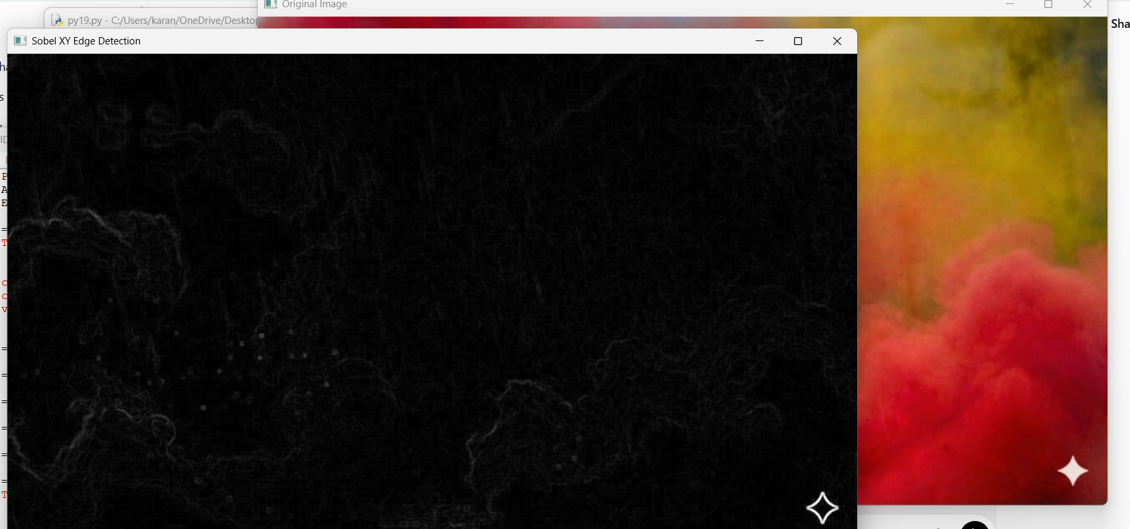
Result
The edges of the given image were successfully detected along both the X-axis and Y-axis using the Sobel Matrix in Python with OpenCV.

